Memorandum 
To: Jeff Fryer
From: Steve Anglea
Re: Bonneville Dam: Adult Fish Facility Entrance and Exit Monitors
CC:
Date: July 31, 2026

The Columbia River Inter-Tribal Fisheries Commission (CRITFC) contacted Biomark to provide PIT-tag detection at the entrance and exit to the Adult Fish Facility (AFF) at Bonneville Dam. The purpose of the entrance detector is to:
1.) Assess salmon behavior as they enter the AFF. Are they committed, or do they turn around if the picket leads are raised? Data from this may help in developing picket lead operation protocols that can better allow fish to pass up the ladder while not biasing the sample in the AFF.
2.) Determine total time of salmon in the AFF and whether there is any bias in the rate that salmon pass through the AFF by age class.
The purpose of the exit detector is to:
1.) Estimate immediate tag loss.
2.) Estimate recovery time from the time a salmon is tagged until it exits the AFF. Assess whether there is any relation between recovery time and upstream detection rate.
3.) Determine whether any tagged fish fall back from the main ladder through the AFF exit and into the AFF.
Exit Channel
The location of the antenna and its interaction with the existing PIT-tag detection system (BO3) is a critical element in determining the placement of the antennas. Personnel from CRITFC, Biomark, and the Pacific States Marine Fisheries Commission (PSMFC) have visited the AFF multiple times over the past two years to evaluate the impact of similarly sized antennas on the BO3 system.
Biomark positioned a pass-through antenna within the BON AFF fish ladder return channel on 25 March 2014 (Figure 1). Inspection of the noise floor, conducted by PSMFC, on the existing BO3 system indicated interference between the existing system and the antenna at this location. Earlier noise listening measurements conducted near the entrance to the channel (Figure 2) did not result in interference with the BO3 system. This location was rejected due to possible disruption of flow and fish striking the antenna (Figure 3). Interference occurred at the alternative location due to the antenna being rotated 90 degrees; this was not taken into account when considering this location for potential antenna placement during the planning phase.
On 26 March 2014, we tested an antenna at the exit to the return channel. The antenna placed at this location did not generate interference on the existing BO3 system. There are two options for placement of an antenna within the exit channel.
Option 1: Install pass-through antenna at exit (Figure 4).
Option 2: Install floating antenna at exit (Figure 5 and Figure 6).

(Note that the locations for these antennas can be found in Figure 12 at the end of this document.) Option 1 would provide the highest detection efficiency as fish are compelled to swim through the antenna. This antenna could be connected to a new IS1001 positioned above the channel. Installation would require one day within the channel.
Option 2 would likely provide acceptable detection efficiency as the nominal detection range of the antenna is 24 inches; water depth is approximately 18 inches. Additional testing will need to be conducted to determine if this antenna in a slightly different orientation results in noise on the BO3 system. The floating antenna could be installed from the deck and operated on a standalone Biomark IS1001 reader placed on the railing above this location (Figure 7). Rigging to secure the antenna would be contained within the existing gate slots.
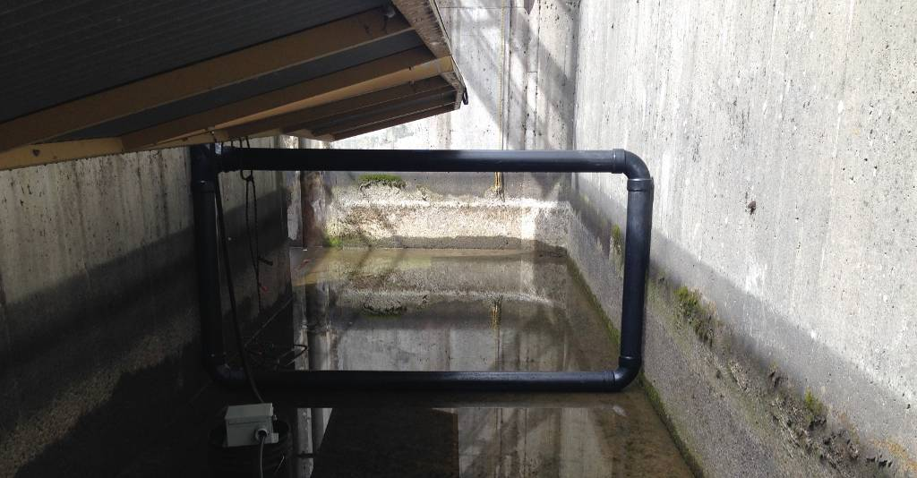
Figure 1. Antenna placed at proposed alternative location. Antenna at this location resulted in elevated noise levels on the existing BO3 system.
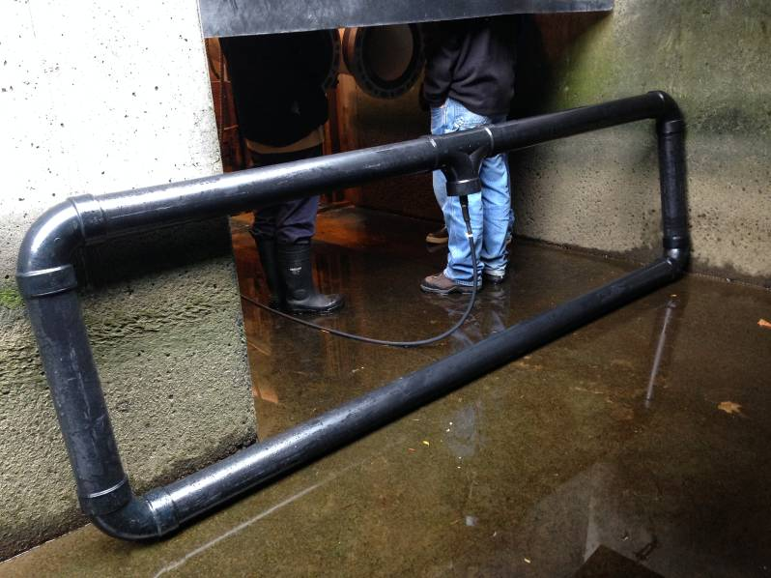
Figure 2. Antenna placed at entrance to BON AFF channel during noise listening survey conducted in fall 2013. This location was rejected due to possible flow disruption and fish strikes.
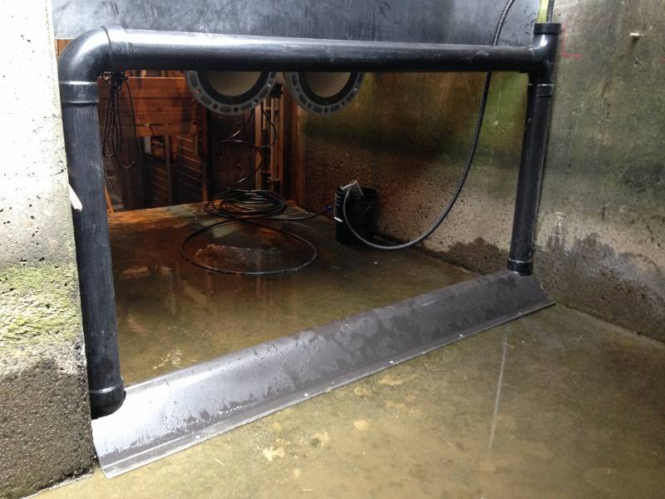
Figure 3. Antenna positioned near the entrance to the exit channel to confirm results from earlier noise listening effort. Fiberglass (FRP) ramps would be used to reduce flow disruption. This location did not result in noise on the BO3 system, but did raise concerns about possible fish strikes and flow disruption.
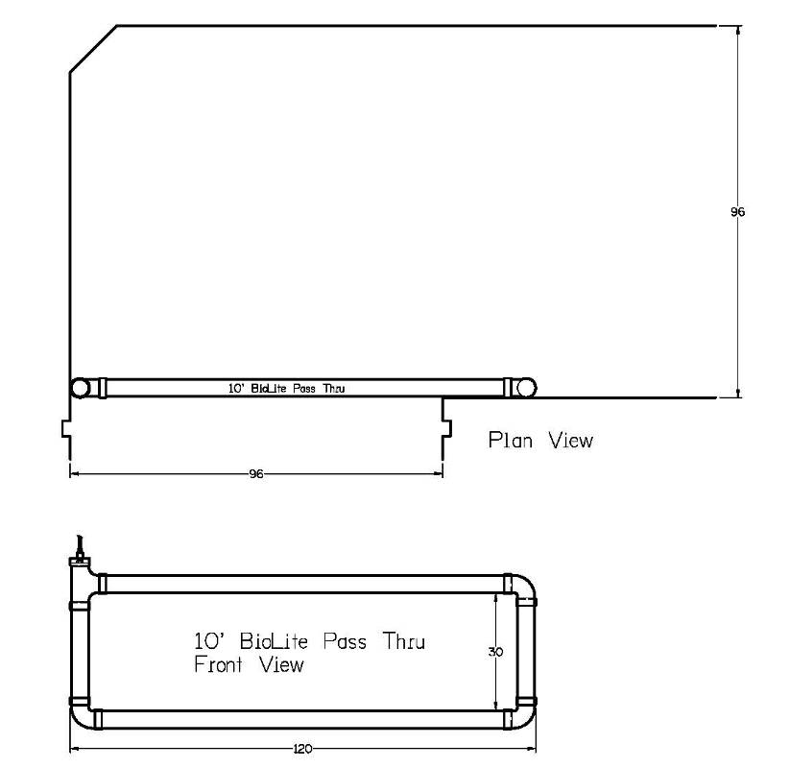
Figure 4. Plan view of potential antenna location at exit to BON AFF channel. FRP ramps would be used to secure the antenna to the channel wall and reduce flow disruption.
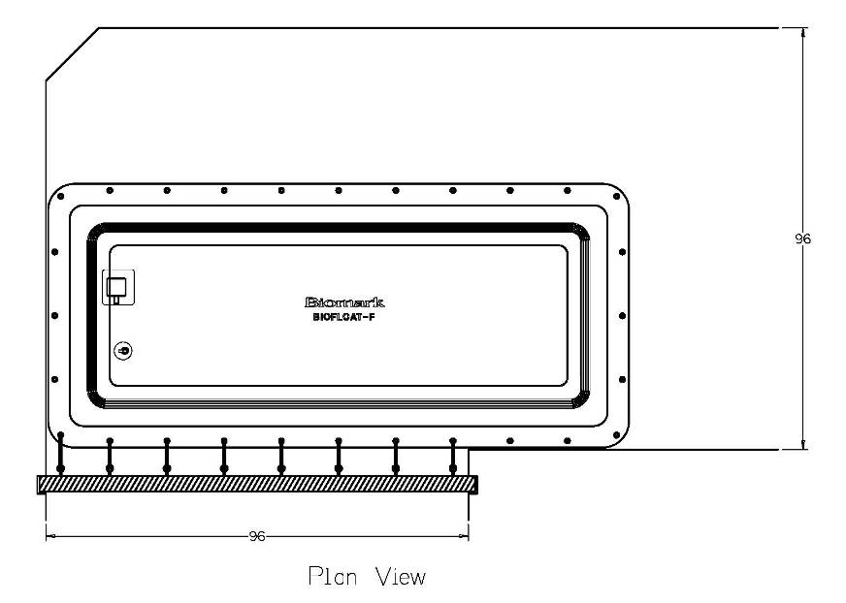
Figure 5. Plan view of 10’ BIO Floating antenna at exit to BON AFF channel. First section of shade cover would need to be lifted up, from deck, to allow installation of the antenna.

Figure 6. Picture of 2-10’ BIO Float antennas installed in the Okanagan River, BC in spring 2014.
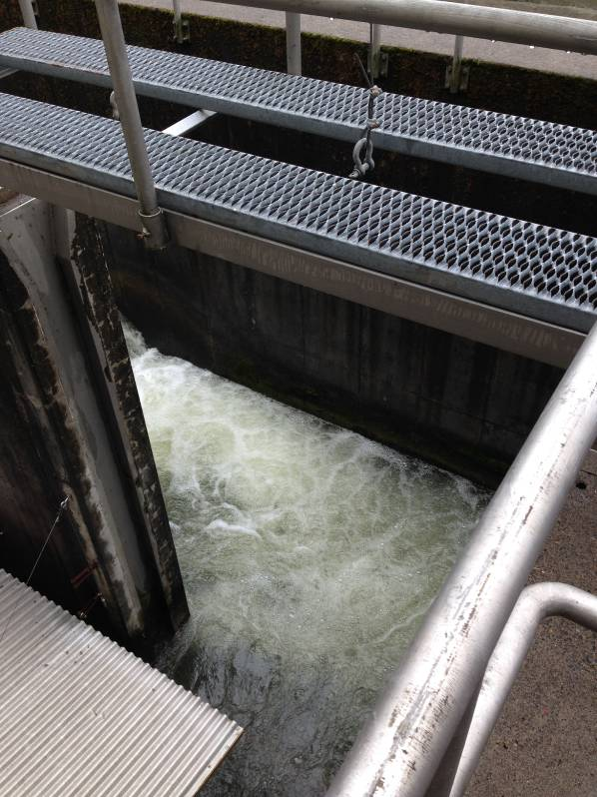
Figure 7. Picture of gate slots at exit to BON AFF channel.

Entrance Channel
An antenna placed within the entrance channel would provide an initial data/timestamp for fish entering the facility (Figure 8). The antenna would likely need to be shielded to mitigate for noise detected during a site visit conducted on 2 October 2014 and to minimize or eliminate any impact on the existing PIT-tag detection system in the adjacent fish ladder (BO3). The antenna would be positioned in the entrance channel upstream of where channel increases in width so as to only protrude from one side of the channel (Figure 9 and Figure 10). The antenna would be secured to the fish ladder walls using FRP ramps to minimize hydraulic disruption and potential impacts to lamprey passage in the ladder (Figure 11). The antenna would be controlled by a Biomark IS1001 reader; synchronized with the exit channel reader. The reader and associated electronics would be placed in a metal weatherproof enclosure and mounted to the outside wall of the AFF.
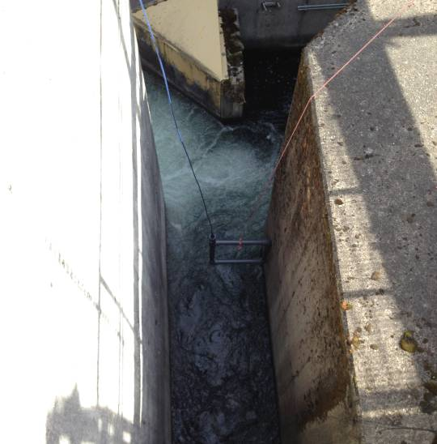
Figure 8. Picture of a noise listening antenna suspended in the AFF entrance channel.
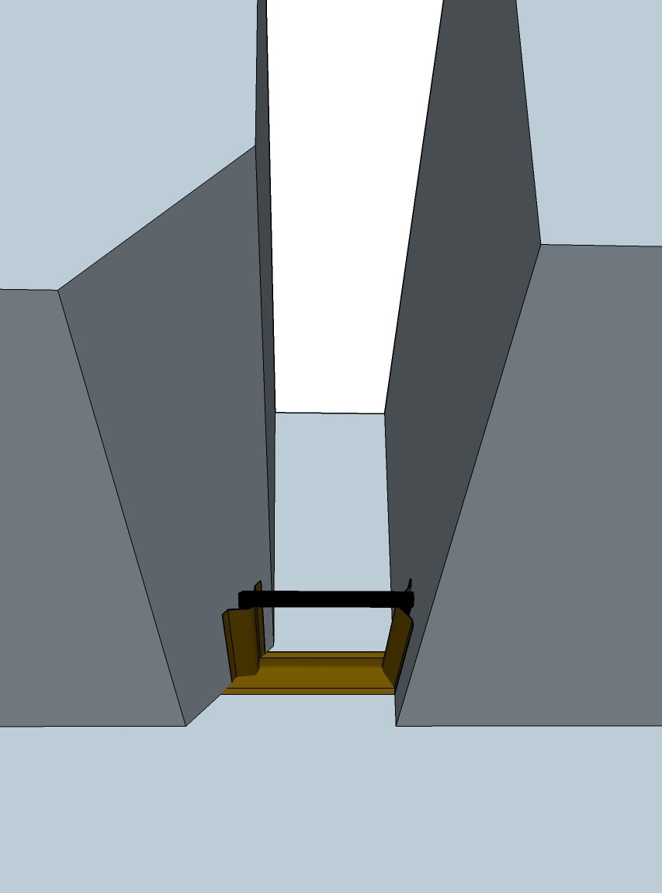
Figure 9. Isometric view of antenna showing curved ramp pieces.

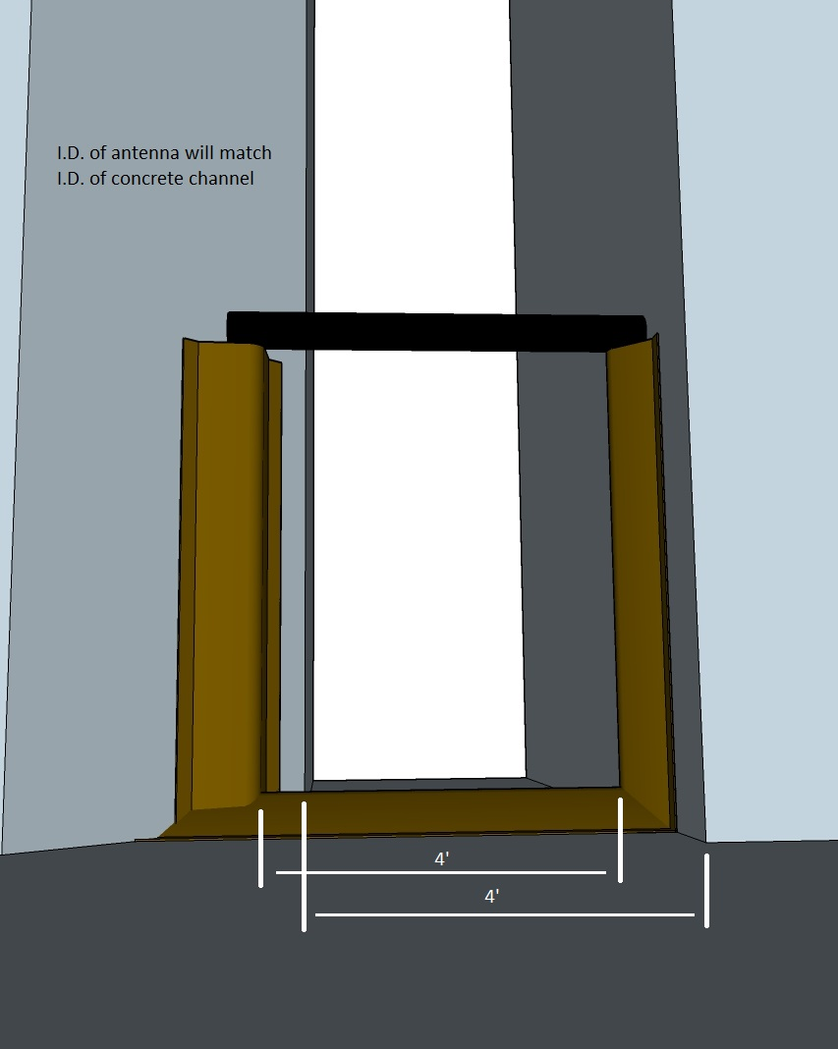
Figure 10. Plan view of antenna in channel showing shift in opening.

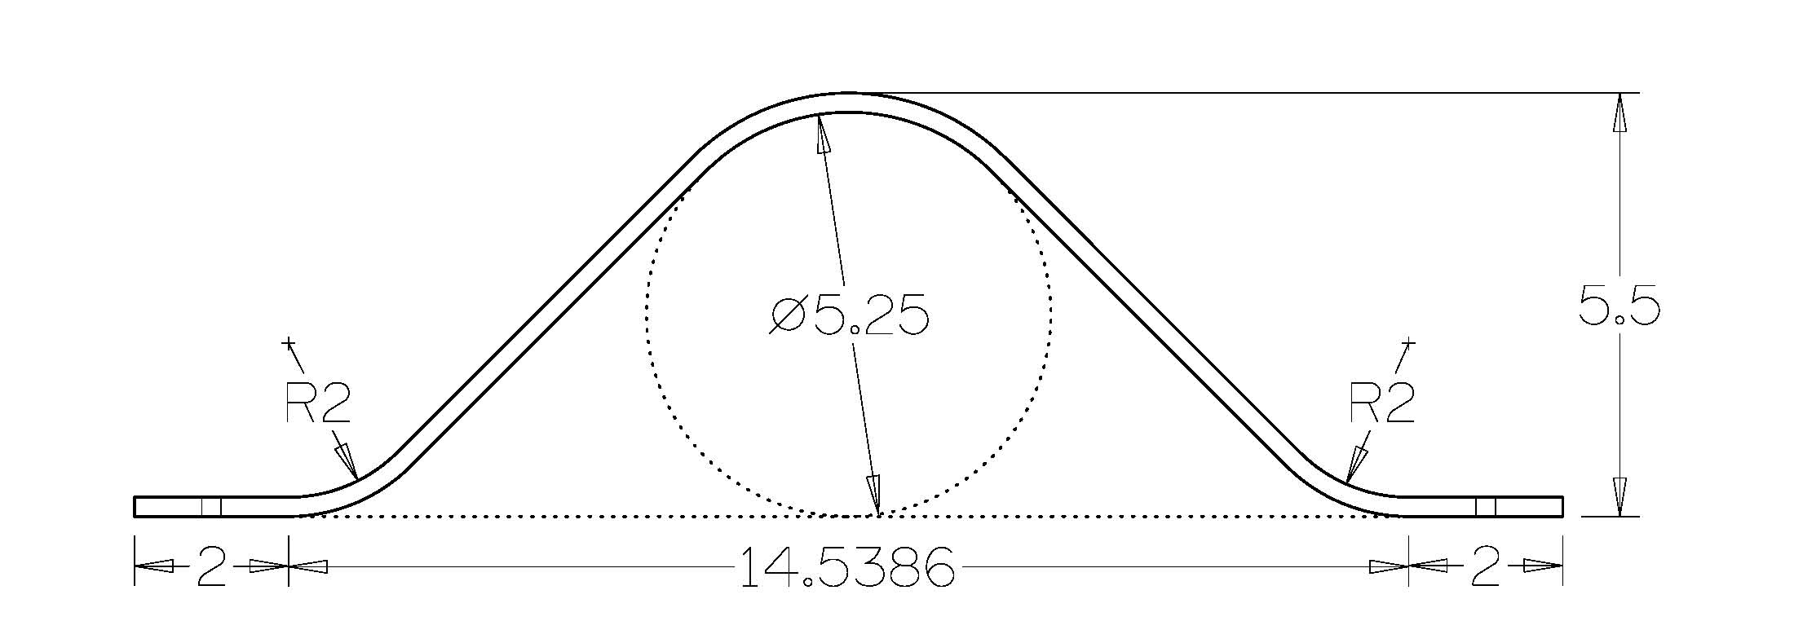
Figure 11. Drawing showing the cross-section of antenna and FRP ramp.
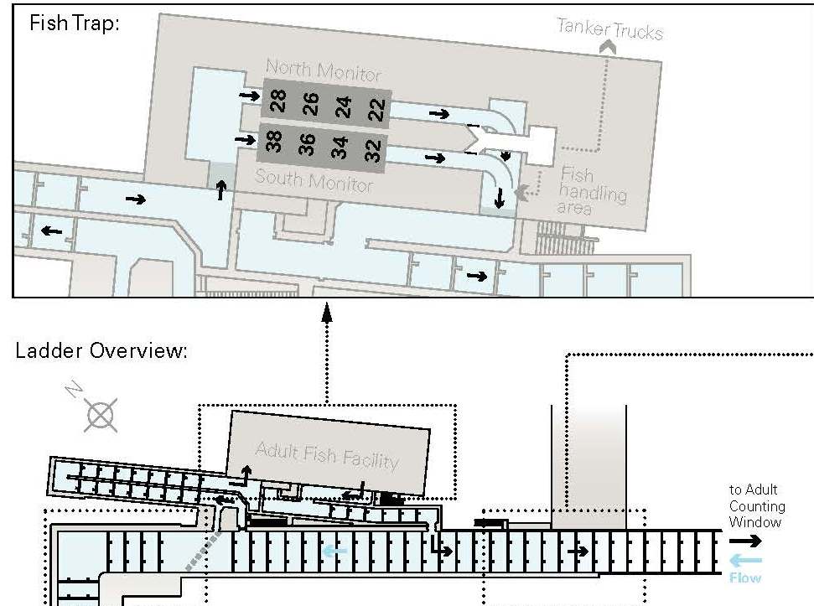
Figure 12. Location of proposed PIT tag detection antennas. The red lines are in-channel antennas while the box is a floating antenna. Note only one antenna would be installed at the exit.

